BN, May 2019  
Customer: KVF  
Project 5527 - Add Text Codes to script 1 button on the comments screen(When processing a SEQ on the GUI)

This project will let user add comments based on text codes already stored in Global Shop at the GUI > Update Jobs

On Line System > Transactions > Shop Floor Data Collection (GUI)

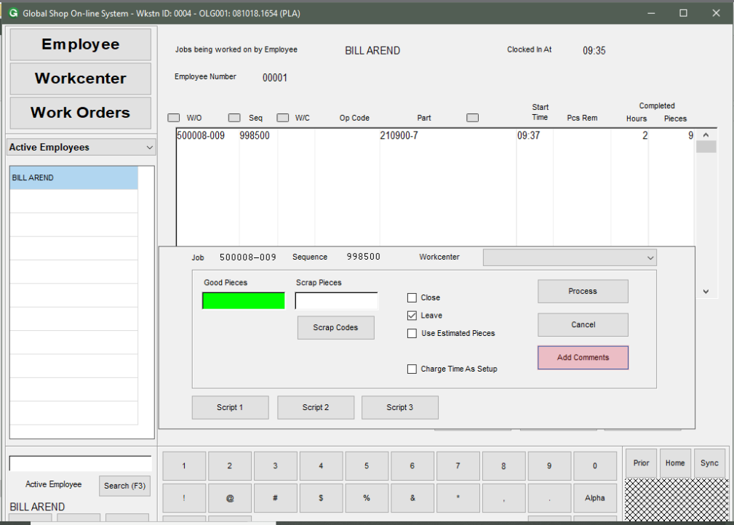

Enter your comments in the text box and click Script 1 button.

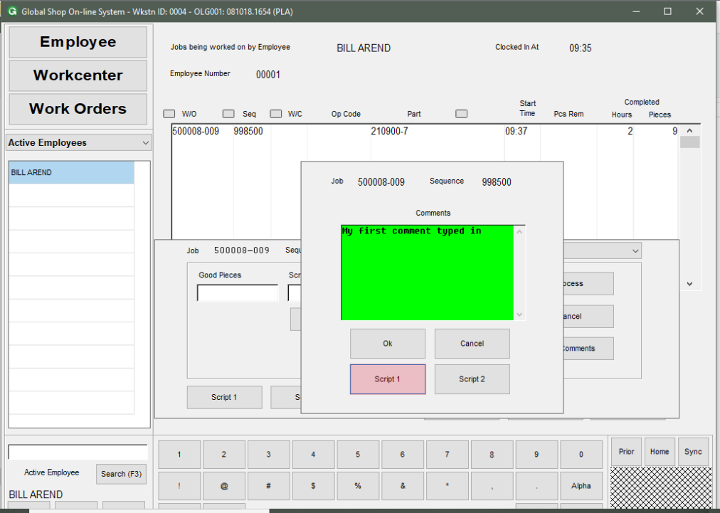

A browser will open to let you select a comments based on codes.

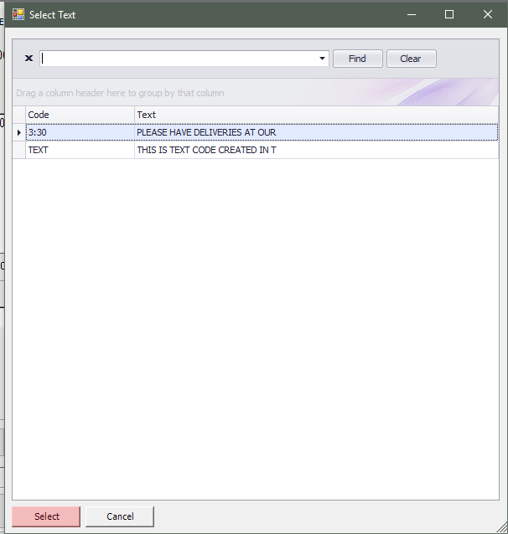

The comments selected will be appended to the comments text box.

